TRUMAN STATE UNIVERSITY
Choral Audition Information Sheet, 2020-21

Name ______________________________________ Year at Truman: Fr Soph Jr Sr Grad

E-mail _____________________________________ Phone ____________________________________

High School: ________________________________ HS Choir Director: _____________________________

Preferred voice part: SI SII AI AII TI TII BI BII

Our Choirs: I am most interested in:
Cantoria (auditioned mixed choir): MTWThF 12:30-1:20 p.m. Cantoria
Voci (auditioned women’s chamber choir): MWF 3:30-4:20 Voci
Chorus (non-auditioned mixed choir): TTh 4:30-5:50 Chorus

Note: due to contagious concerns about large gatherings, the Fall 2020 choirs will work differently than usual. We have plans for small-group, in-person work with Cantoria and Voci, whereas Chorus will meet primarily online in synchronous sessions. ALL CHOIRS will make extensive use of technology, and students will work to build skills through the semester. Choral events have, unfortunately, been suspended for the term. When we will be able to resume larger gatherings of people, we will resume concert activities.

Auditions for Cantoria and Chamber Choir are for YEARLONG membership in the ensemble. Initial here if you understand that by accepting a spot in an auditioned choir, you will make every effort to keep the yearlong commitment: _________

If you have health concerns about any group singing but would still like to participate, contact Dr. Jennings: mdj@truman.edu

Song that you will be singing for this audition: _____________________________________________
Choral experiences (high school or college)

Musical honors (all-district or all-state chorus; ratings for solos; etc.)

Years of private voice study (if any) ____ Voice teacher _________________________
Instruments played: piano____ (# years played); other instrument: ____________________ (# years played)

On a vocal scholarship at Truman? Yes No
(do not write below line)

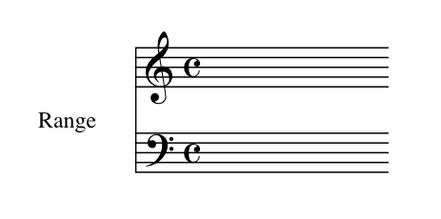

Voice quality 1 2 3 4 5 Best characteristics:
Intonation 1 2 3 4 5
Rhythmic accuracy 1 2 3 4 5
Tonal memory 1 2 3 4 5
Sight reading 1 2 3 4 5
Overall impression 1 2 3 4 5

Recommended ensemble: Cantoria Voci University Chorus

Recommended voice part: S1 S2 A1 A2 T1 T2 B1 B2

